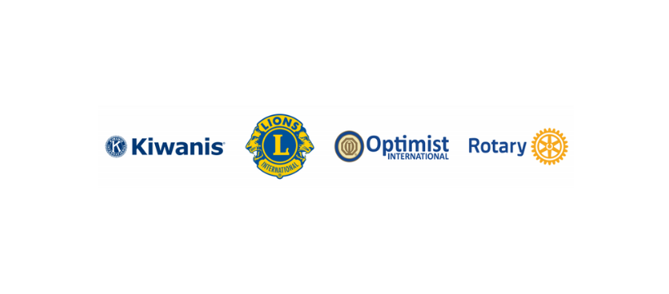

NEWS RELEASE

[INSERT TOWN] Kiwanis, Lions, Optimist and Rotary clubs will join forces to address [INSERT ISSUE, E.G., HUNGER]

Part of a global service week initiative to strengthen communities and improve lives

CITY, STATE (DATE) – Community service will take center stage the week of Sept. 8-14 as local area Kiwanis, Lions, Optimist and Rotary clubs address [INSERT ISSUE, E.G., HUNGER] during the service organizations’ fourth annual Celebrate Community initiative.

Together, the [INSERT TOWN] clubs will [INSERT ISSUE WITH SUPPORTING DATA – IF AVAILABLE - TO BE ADDRESSED WITH DESCRIPTION OF PROJECT]. [INSERT DATE, TIME, LOCATION AND ANY PROMINENT COMMUNITY MEMBERS IN ATTENDANCE.]

[INSERT QUOTE (S) FROM LOCAL SERVICE PROJECT STAKEHOLDERS

Leadership from the service organizations Kiwanis International, Lions International, Optimist International, and Rotary International have encouraged their clubs and youth programs around the world to work together on projects during one week as part of a joint initiative dubbed Celebrate Community – #CelebrateCommunity. Issues related to health and wellness, food insecurity and hunger, education and literacy, and the environment will be addressed through community cleanups, food donations and distributions, walks or runs to raise money for specific causes and book collections for children.
About Kiwanis: Founded in 1915, Kiwanis International is a global organization of clubs and members dedicated to serving the children of the world. Each year, the Kiwanis family of clubs devote more than 7.7 million hours of service. Kiwanis clubs sponsor adult and youth leadership programs and conduct more than 1.3 million projects. Through service projects and fundraisers, Kiwanis members improve their communities, make lifelong friendships and, most importantly, help children reach their full potential. Visit kiwanis.org for more information.
About Lions: Lions International is the largest service club organization in the world. More than 1.4 million members in over 49,000 clubs are serving in 200 countries and geographic areas around the globe. Since 1917, Lions have strengthened local communities through hands-on service and humanitarian projects, and we extend our service impact through the generous support of our Lions Clubs International Foundation. We are focused on supporting vision, the environment, childhood cancer, hunger, diabetes, and other pressing humanitarian needs to help address some of the biggest challenges facing humanity. For more information about Lions International, visit lionsclubs.org.
About Optimist: Optimist International, founded in 1919, is a service organization serving youth and communities around the globe. It has nearly 70,000 adult and youth members in more than 2,000 clubs throughout the world. Carrying the motto “Bringing Out the Best in Youth, in our Communities, and in Ourselves,” Optimists conduct positive service projects that reach more than six million young people each year. To learn more about Optimist International, please call 314-371-6000 or visit the organization’s website at www.optimist.org.
About Rotary: Rotary brings together a global network of volunteer leaders dedicated to tackling the world’s most pressing humanitarian challenges. Rotary connects 1.4 million members of more than 46,000 Rotary clubs in over 200 countries and geographical areas. Their work improves lives at both the local and international levels, from helping those in need in their own communities to working toward a polio-free world. For more information, visit Rotary.org.
###
CONTACTS:
NAME, PHONE, EMAIL [INSERT ONE CONTACT FROM EACH PARTICIPATING ORGANIZATION]

